Task Description#2

* Use Copilot to generate a is_prime() Python function.

Excepted output#2

* Function to primality with correct logic.

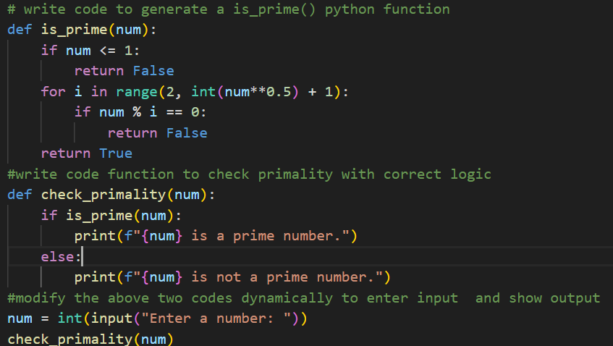

**OUTPUT**:

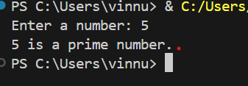

Task Description #3

* Write a comment like #Function to reverse a string and use copilot to generate the function.

Expected Output#3

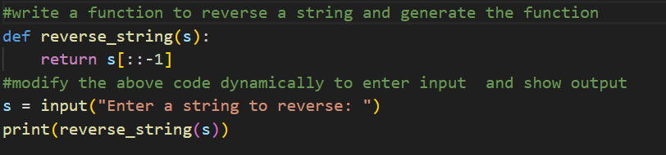

**OUTPUT**:



Task Description#4

* Generate both recursive and iterative versions of a factorial using comments.

Expected Output#4

* Two working factorial implementations

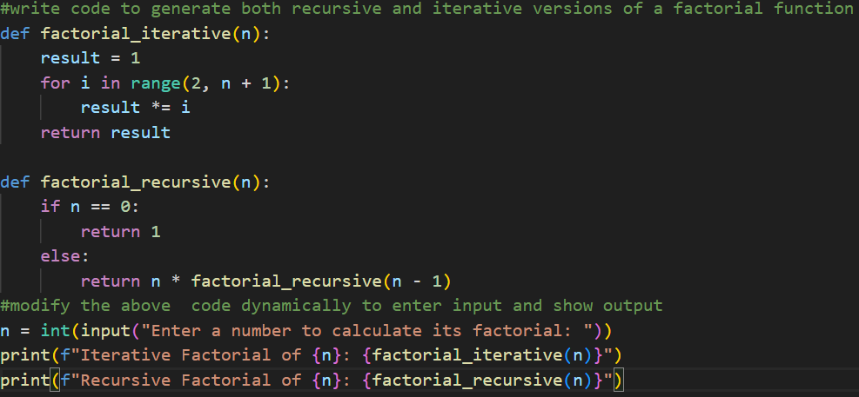

**OUTPUT**:

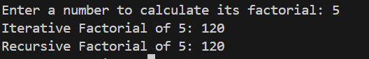

Task Description #5

* Use copilot to find the largest number in a list.Assess code quality and efficiency.

Expected Output#5

* A valid function with your review

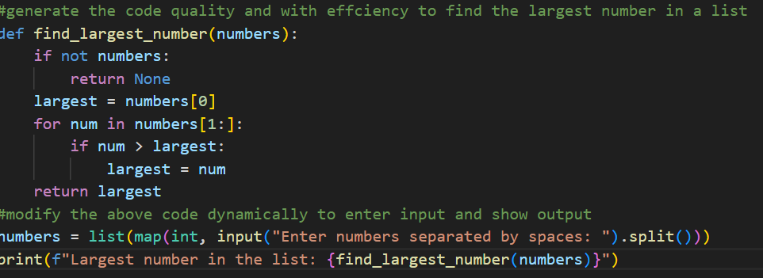

**OUTPUT**:

